April posts for website and FB
Behind the Scenes of the Prairie Flyers:
Week 1:
The changing role of women in aviation
For Bev Hartsock, aviation offered a chance to see the world beyond her backyard in the tiny village of Kenney.
Bev was one of many Midwesterners referred to us by her friends who knew her dream of learning to fly. People we talked to during research for our exhibit and later, a book on aviators and aviator lovers, were eager to tell us Bev’s story. After all, isn’t there something daring and magical about people who want to fly?
Bev graduated high school in the 1950’s during a time of limited career opportunities for women. After her goal of going to flight school was set aside for financial reasons, Bev looked at becoming a stewardess.
“I wasn’t interested in getting married, being a teacher or any of the other options open to most women,” Bev told me over a cup of coffee at her kitchen table.
Bev’s story, included in Prairie Flyers of Central Illinois: A Century of Aviation in America’s Heartland, illustrates the rise and fall of women’s efforts to earn a living in the field of aviation. Bev found her way to a career with Ozark Airlines in an unexpected, behind the scenes job. Her story will resonate with women who experienced similar challenges on their way to living the dream of a career in aviation.

Week 2
From Gemini to plane builder
Richard Snelson was halfway through his teen years when he had the chance to take a plane ride over the Missouri River outside Wainwright.
The love affair with aviation lasted a lifetime.
Snelson was long retired when we met to talk about his career as an engineer for the Gemini space project in St. Louis. His animated storytelling told me all I needed to know about his affection for flying and building airplanes. His wife Roxanne was literally along for the ride—as a support person for his career and passenger in the planes he flew and built. She has her share of stories, too.

In Prairie Flyers of Central Illinois: A Century of Aviation in America’s Heartland, Snelson shares his story of constructing the EAA Thorp T-18 at his home in central Illinois. To say the project took years of commitment is an understatement.
From our interviews, it was clear that the people who love to fly and work around planes view the world with a slightly larger lens than the rest of us. Where we look up to see the sky, their field of vision perpetually includes the sky. Richard Snelson is one of those people.

Week 3:
Author recalls Vietnam helicopter duty
Most pilots fortunate enough to walk away from helicopter duty in Vietnam thanked God for their good fortune and moved on with their lives.
David Henard took a different path after he returned home in 1969 from his time in the U.S. Army. In our interview in the living room of his home, he recalled the sheer joy he felt the day he left Vietnam for home but that joy and relief to be coming home in one piece did not keep him from his next mission to chronicle his experiences in a book.
Victory Stolen: The perspectives of a helicopter pilot on the Tet Offensive and its aftermath was published by Henard in 2018. There is no substitute for a firsthand account of time spent in a war zone and the dangers faced every second a pilot is in the air.
Henard’s story is part of a collection, Prairie Flyers of Central Illinois: A Century of Aviation in the America’s Heartland, scheduled for publication in June by The History Press. The stories are written by Denis Hambucken, John Warner and me, based on an exhibit we put together in 2022 for the C.H. Moore Homestead and DeWitt County Museum.
Week 4:
Remembering a hometown hero
As a kid, Henry Kleemann raised pigs for a 4-H project and helped out on the family farm.
He was one of those kids destined to go places after he left high school. Voted “most likely to succeed” by his classmates, Kleemann attended the U.S. Naval Academy.
Kleemann’s military and academic career were enough to earn him the status of hero. In 1981, an incident involving Kleemann’s F-14 and two Libyan fighters in the Gulf of Sidra put him on the front page of the New York Times.
But it was his death in 1985 that put Kleemann forever on the list of heroes for folks in Illinois and across the country. With 128 combat missions and a Bronze Star for valor in Vietnam, Kleemann was a role model for his classmates and everyone who knew him.
When people talk about Midwestern military aviators, Kleemann’s name is on the list of what it means to serve and die with honor. His story is proudly included in Prairie Flyers of Central Illinois: A Century of Aviation in America’s Heartland. The book will be available this summer.

Facebooks posts with photos
Week 1:
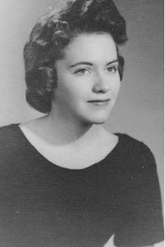
Bev Hartsock dreamed of being a pilot, then a stewardess after high school but the cost of flight school and the career limitations placed on women in the 1950’s put her a one different path in the field of aviation. Anyone old enough to remember Ozark Airlines will appreciate her story.
Bev’s story is part of a collection of stories written by Denis Hambucken, John Warner and me, set to be published this summer by The History Press. The Prairie Flyers of Central Illinois: A Century of Aviation in America’s Heartland, includes tales of barnstormers, stunt pilots, military aviators, and the people who work behind the scenes like Bev to keep the planes in the air.
T0 read more about Bev, visit (Link).
Week 2:
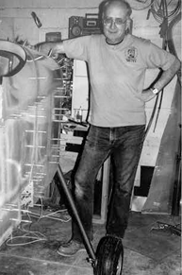
There wasn’t much Richard Snelson was unwilling or unable to do in the field of aviation.
As an engineer, he worked on the Gemini space project, obtained his pilot’s license and built his own EAA Thorp T-18 at his home in Clinton. Snelson’s is one of dozens of aviator stories included in Prairie Flyers of Central Illinois: A Century of Aviation in America’s Heartland set for publication this summer by The History Press.
Snelson and his wife Roxanne loved everything about flying—the friends they met, the time spent building the plane and the hours they shared in the air. It was a pleasure for me and my co-authors Denis Hambucken and John Warner, to get to know the subjects of the book.
To read more about Snelson visit edithbradylunny.com.

Week 3:
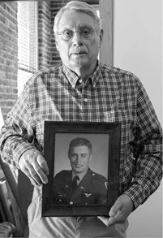
In one of our first conversations for Prairie Flyers of Central Illinois: A Century of Aviation in America’s Heartland, David Henard told me why he never questioned his plan to sign up for military duty.
The family history of military service ran deep.
“I just grew up feeling like I had an obligation to serve my country,” he said.
After ROTC, the Missouri native joined the U.S. Army and found himself training as a helicopter pilot, heading to Vietnam. Henard’s experiences are chronicled in his 2018 book Victory Stolen, that includes his analysis of the Tet Offensive.
The long-lasting pain of lost lives still comes through in Henard’s recollection of his time in Vietnam. You can’t read his story without feeling the grief that never quite goes away.
Henard is one of several helicopter pilots who shared their stories with us for the book set to be released in June. Denis Hambucken and John Warner also authored stories for the book based on their conversations with aviators and aviation lovers.
To read more about Henard, visit Edithbradylunny.com link

Week 4:
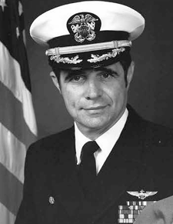

People who remember Henry Kleemann as a child describe a farm kid who took Chester White pigs to the state fair. They marveled at his admission to the U.S. Naval Academy and the fact he flew F-14 Tomcats like the ones in the movies.
Later, Henry was remembered as a hero-aviator who tangled with Syrian fighters over the Gulf of Sidra. His tragic death in 1985 during a flight in California brought loved ones together to remember a lifetime of accomplishments.
Doris Keane, Henry’s sister, told me she was not surprised that her brother’s aviation career soared. He was the brightest and most focused kid she had ever known. He was destined to succeed and died doing the thing he loved most, she said.
Readers can learn more about Henry Kleemann in Prairie Flyers of Central Illinois: A Century of Aviation in America’s Heartland, a collection of stories by Denis Hambucken, John Warner and me. The book will be released this summer.
To learn more about Henry Kleemann, visit edithbradylunny.com.

